Please respond to Tim Heilbronn, Deacon of the Dyer Craft of Dundee
74a Errol Road, Invergowrie, Dundee DD2 5AF
t.d.heilbronn@dundee.ac.uk 01382 384205 (w), 01382 52517 (h), 07754 271562 (m)

27th October 2014

Dear Young Photographers

January 2015 sees the 100th anniversary of the death of Mary Slessor. As some of you will already know, Mary Slessor left her work as a weaver in Dundee to go to Africa to work with the people who lived in what is now called Nigeria. Mary Slessor’s life was quite remarkable and you have an opportunity to find out more about her, and be involved in two competitions.

I am writing to invite you to submit up to three photographs taken by you, which have been inspired by your research. A separate writing competition is being organised by the Nine Trades of Dundee (of which the Dyer Craft is one of the Nine), and you will also receive information about this.

There are cash prizes for the best photographs, and further details of the prizes, and age groups, are shown on the Information Sheet / Entry Form which should be submitted with your photographs.

I wish you well as you find out about the remarkable Mary Slessor, her life and her times, and I look forward to seeing your photographs.

With best wishes

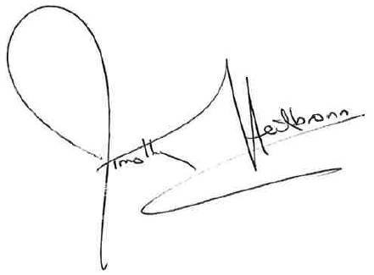

Tim Heilbronn

Deacon, The Dyer Craft of Dundee

